**DAILY ONLINE ACTIVITIES SUMMARY**

|  |  |  |  |  |  |  |  |
| --- | --- | --- | --- | --- | --- | --- | --- |
| **Date:** | **11/06/2020** | | | | **Name:** | Tushit Shukla | |
| **Sem & Sec** | **4 SEM & B SEC** | | | | **USN:** | **4AL17CS005** | |
| **Online Test Summary** | | | | | | | |
| **Subject** | | - | | | | | |
| **Max. Marks** | | **-** | | **Score** | | **-** | |
| **Certification Course Summary** | | | | | | | |
| **Course** | **JAVA PROGRAMMING** | | | | | | |
| **Certificate Provider** | | | **Great Learning** | **Duration** | | | **1.5 hr(spent by me on that day to learn)** |
| **Coding Challenges** | | | | | | | |
| **Problem Statement:**  Given an array A[], write a function that segregates even and odd numbers. The functions should put all even numbers first, and then odd numbers. Example:  Input = {12, 34, 45, 9, 8, 90, 3} Output = {12, 34, 8, 90, 45, 9, 3}  Algorithm: segregateEvenOdd()   1. Initialize two index variables left and right: left = 0, right = size -1 2. Keep incrementing left index until we see an odd number. 3. Keep decrementing right index until we see an even number. 4. If lef < right then swap arr[left] and arr[right] | | | | | | | |
| **Status: Completed** | | | | | | | |
| **Uploaded the report in Github** | | | | **Yes** | | | |
| **If yes Repository name** | | | | <https://github.com/tushitshukla29/lockdown-program> | | | |
| **Uploaded the report in slack** | | | | **Yes** | | | |

**Online Certification Details**

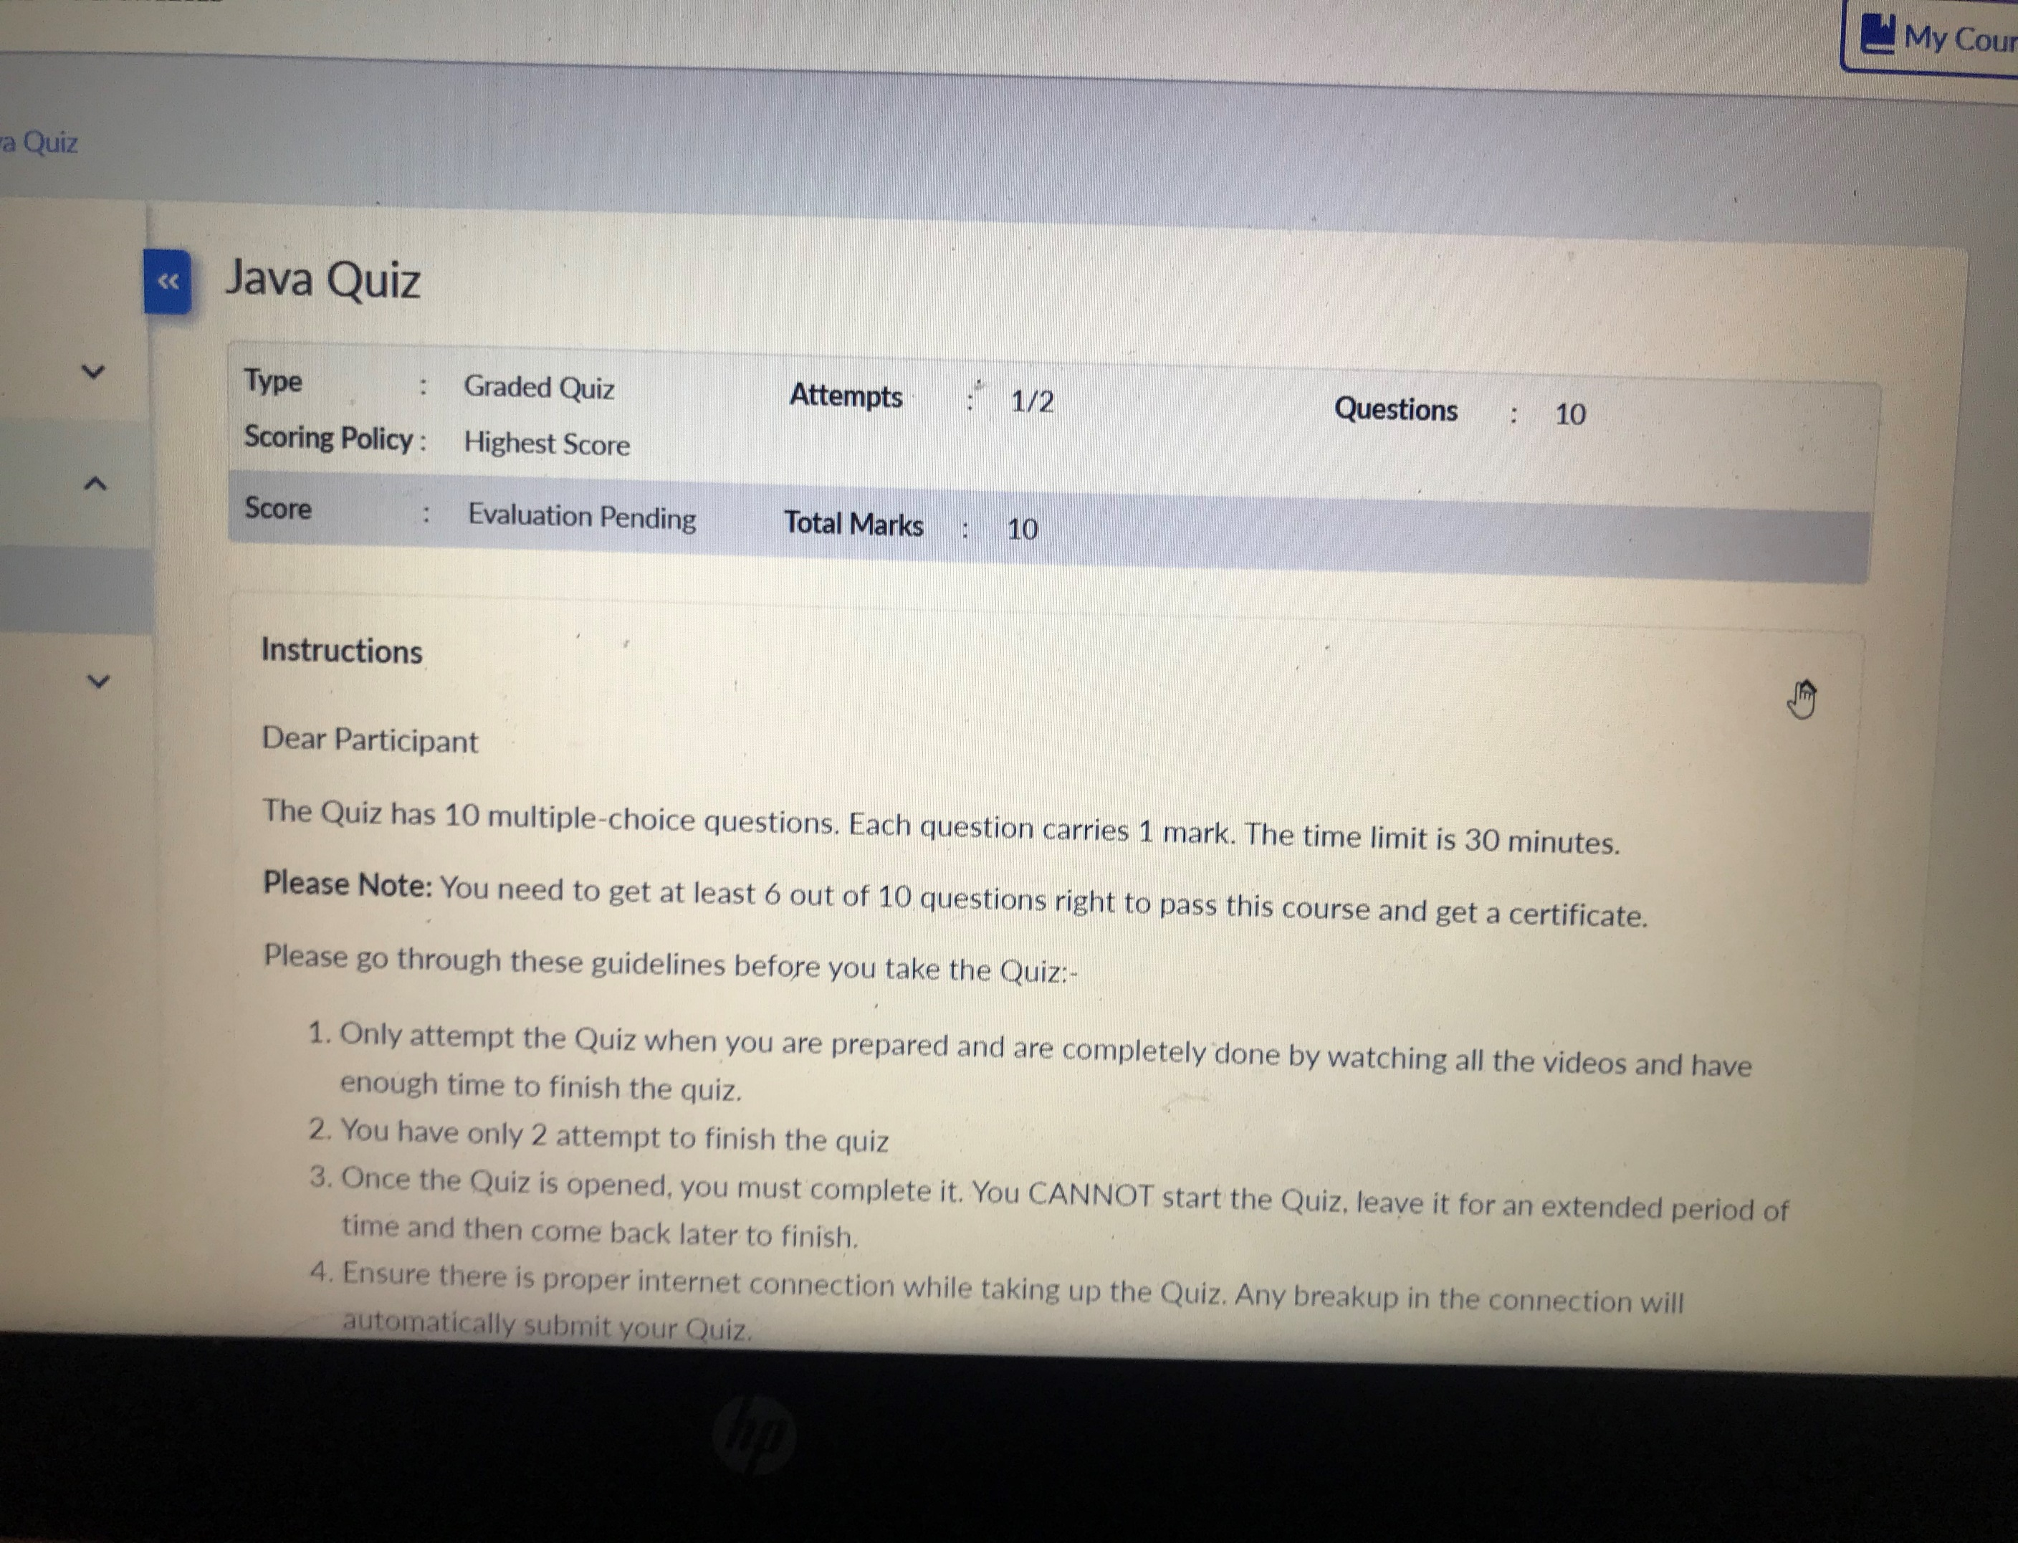

**Coding Challenge Details**

1. <https://github.com/tushitshukla29/lockdown-program/blob/master/SegregateOddEven>